# Draft Marsh Fritillary tree planting risk layer proposal- Scottish Forestry

## Background and approach

In the coming year, Scottish Government will raise its ambition and commit to planting 12,000 hectares, supported by additional investment[1]. Scottish Forestry has been working with Butterfly Conservation to find ways to help inform tree planting in a positive way that won’t impact on priority Lepidoptera. During phase 1 of this work, two major datasets held by Butterfly Conservation were investigated to scope their use as a risk/opportunity layer for tree planting in Scotland. The work involved compiling ecological trait attributes to inform impacts of different types of tree planting based on Scottish woodland prescriptions. The conclusion of this first phase of work is that we need to test a species distribution modelling approach.

The best species to test is the Marsh Fritillary butterfly. As a European Protected Species for which we have the best data, including a site Dossier for Scotland, the Marsh Fritillary is a good test case. The UK Butterfly Monitoring Scheme produces trends for Marsh Fritillary in the UK, England, Wales and Northern Ireland. There are currently not enough monitored sites to produce a trend in Scotland. Trends show non-significant long-term decline in the UK (-13%,1981-2018) and Wales (-65%, 1990-2018), a significant decline in England (-66%, 1983-2018, p=<0.05) and a non significant increasing trend in Northern Ireland (16%, 2004-2018). The Marsh Fritillary butterfly is only found in Scotland in south Lochaber, Argyll and the Argyll Islands. Comparing the site dossier data, the percentage of occupied landscapes is highest in Scotland at 50% compared with 38% in England, 39% in Wales and 44% in Northern Ireland. The Scottish population of this species represents some of the most important colonies across Europe. In the absence of abundance trends in Scotland, there is emerging evidence to support the importance of Scottish Marsh Fritillary colonies in a UK and European context.

The long-term survival of the Marsh Fritillary relies on extensive grazing, ideally by traditional breeds of cattle, to maintain its habitat in suitable condition. Suitable sites are open, unshaded but often sheltered with abundant patches of devil’s-bit scabious, the caterpillar’s sole foodplant.

The approach will be to create a risk layer for tree planting based on dossier data for extant sites in south Lochaber, Argyll and the Argyll Islands and a modelled layer to represent the likely distribution. The layer will provide landowners with advanced warning that a priority species may be present on sites they are considering for woodland expansion and suitable survey and mitigation may be required.

## Brief summary of species distribution modelling applied to Marsh Fritillary in Scotland

We use species distribution models (SDMs) to predict the potential distribution (in terms of suitable habitat/climate) of Marsh Fritillary in Scotland, to help inform the production of a risk/opportunity layer for tree planting in Scotland.

### Marsh Fritillary data preparation

Presence records of Marsh Fritillary for Scotland were obtained from the BC Scotland dossier for 2000-2017. The spatial extent for the modelling was defined by a 20km buffer applied to the min/max easting and northing of Marsh Fritillary records (i.e. to form a square).

Absence records were produced using records of other butterflies from the Butterflies for the New Millennium (BNM) database for 2000-2017 made within May - July when Marsh Fritillary adults are most likely to be recorded as a surrogate for recording effort. The data were limited to records of adults with at least 1km resolution, falling within the spatial extent defined above, and with at least 3 records during 2000-2017.

### Environmental variable

We used land cover data from the CEH land cover map 2015 at 1km resolution (Rowland et al. 2017) which consists of 21 land cover classes. We removed several classes which had low coverage in the region of interest, hence we initially considered the following classes: broadleaf woodland, coniferous woodland, arable, improved grassland, acid grassland, heather, heather grassland, bog, and urban (combined from the urban and suburban target classes). Elevation data was sourced from OS Terrain 50 in gridded format.

Average mean summer temperatures (for 2000-2017) were derived from HadUK-Grid data (Hollis et al 2019). Average temperatures for other seasons were also considered, but not used in the analyses due to the high correlation with summer temperature. Rainfall was also considered but highly correlated with elevation hence also ignored.

### Modelling

We applied species distribution models (SDMs) to the data for Marsh Fritillary at 1 km square resolution using the Biomod2 package in R (Thuiller et al 2009, 2019). Seven different individual model types were applied: GLM, GBM, GAM, RF, MARS, CTA and ANN. The data were randomly split into training/calibration (70%) and testing/evaluation (30%) data for 10 runs of each model (70 models fitted in total). Average variable importance (across models and randomised data) was assessed and broadleaf woodland, arable, acid grassland, heather and urban were removed in subsequent model runs (thus retaining coniferous woodland, improved grassland, heather grassland, bog, summer temperature and elevation). Based on having the lowest average AUC (Area under the Curve) values, RF, CTA and ANN were excluded from the model ensembles.

Ensemble modelling was applied using a weighted average of the individual model evaluation metrics (alternative approaches were also briefly checked and showed minimal effects on the evaluation metrics). Models were primarily evaluated using the area under the curve (AUC) of the receiver operating characteristic (ROC), as well as sensitivity (the proportion of correctly predicted presences) and specificity (the proportion of correctly predicted absences). AUC measures the performance of a model to discriminate between sites where a species is present versus those where it is absent. AUC values of 1 represent a perfect fit whereas a value of 0.5 indicates a model that is as good as random. The final maps presented are based on an ensemble of the 4 best individual models applied to the full data set. Maps could also be produced for the coefficient of variation of the predictions from the 4 individual models, to describe some of the underlying uncertainty in the predictions.

The map below is based on the model predictions that are scaled between 0 and 1. These scores can be thought of as relative probabilities of Marsh Fritillary being present. The actual scores for the model presented range from 0.27 to 0.665. The map has been restricted to a buffer region within 20km of the dossier occupied 1km squares.

### 

Figure : Species distribution modelling output and actual 1km square distribution of Marsh Fritillary in Scotland

## Creating the risk scores and map outputs

To convert the model outputs to meaningful instructions to Forestry Advisors, the relative probabilities need to be converted to risk categories for the 11930 1km squares considered in the model.

At the 1km level we have assigned three risk categories- present, potential, uncertain with the threshold of potential set at three levels: 1) 0.5 as 50% of total score potential, 2) 0.346 as 50% of the score derived between 0.27 and 0.665 and 3) 0.183 which is the optimised model prediction cut off value.

The maps below display the three different threshold values which distinguish between ‘Potential’ and ‘Uncertain’. 1km squares with Marsh Fritillary recorded as ‘Present’ remain the same, as derived from the species dossier data.

## Threshold between uncertain and potential at 0.5

At this level, the model predicts 11,495 squares in the region to be uncertain and 251 (2.1% of model total and 0.29% of Scotland) to be ‘potential’ for Marsh Fritillary.

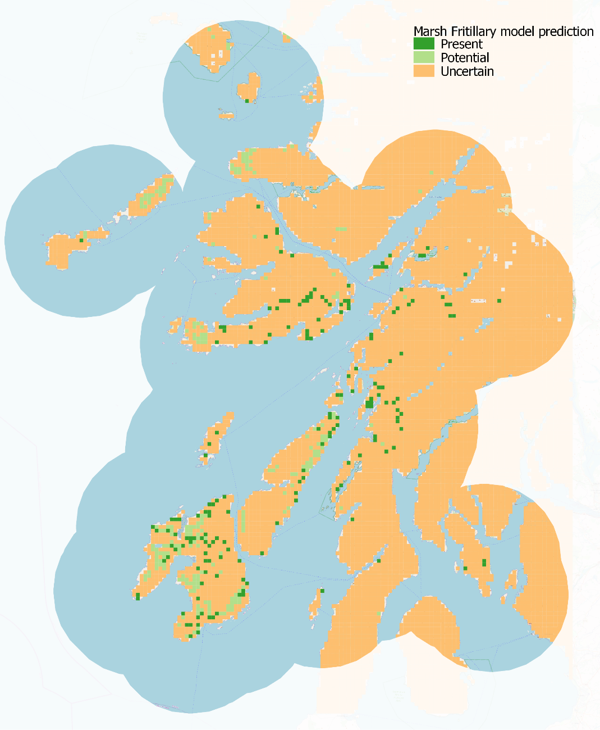

## Threshold between uncertain and potential at 0.346

50% of the score derived between 0.27 and 0.665. At this level, the model predicts 10,825 squares in the region to be uncertain and 921 (7.7% of model total and 1.07% of Scotland) to be ‘potential’ for Marsh Fritillary.

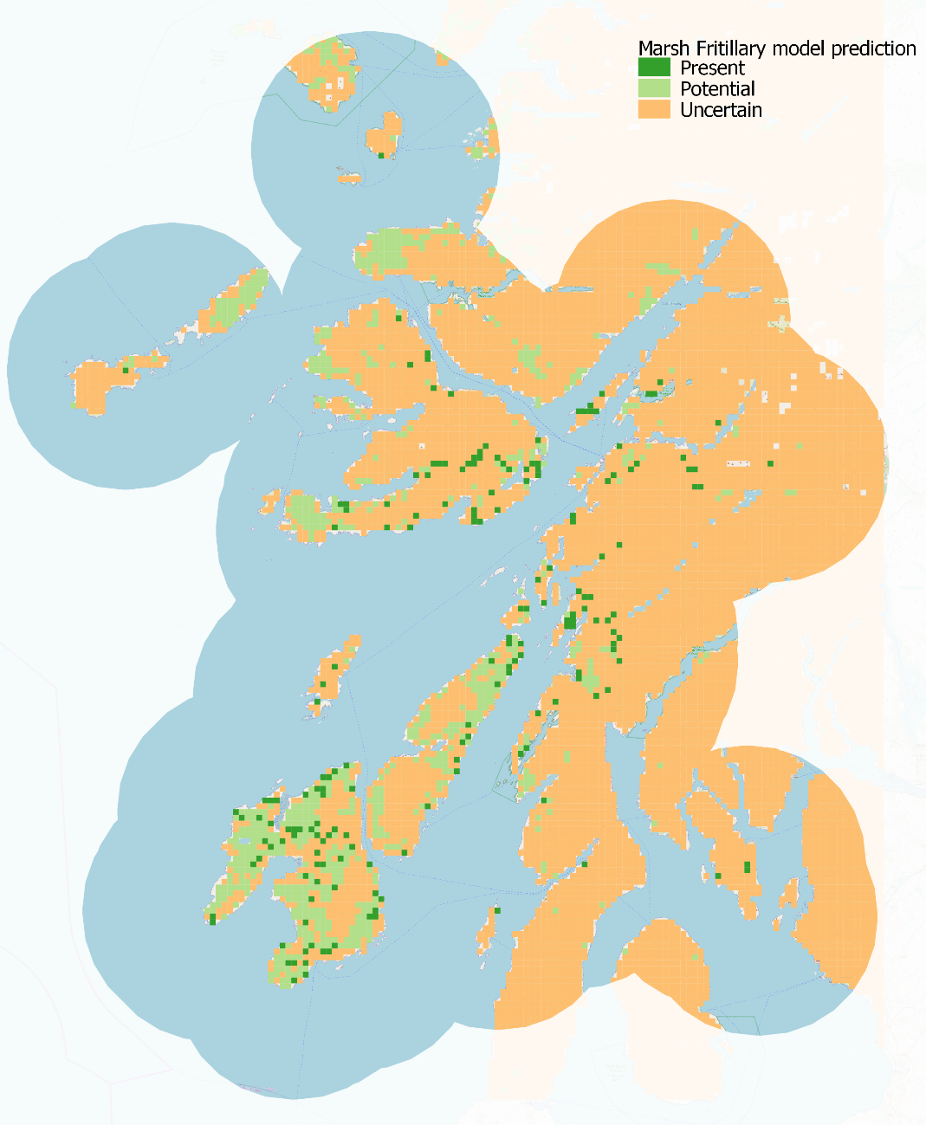

## Threshold between uncertain and potential at 0.183

The optimised model prediction cut off value is 0.183. At this level, the model predicts 8,289 squares in the region to be uncertain and 3457 (29% of model total and 4.01% of Scotland) to be ‘potential’ for Marsh Fritillary.

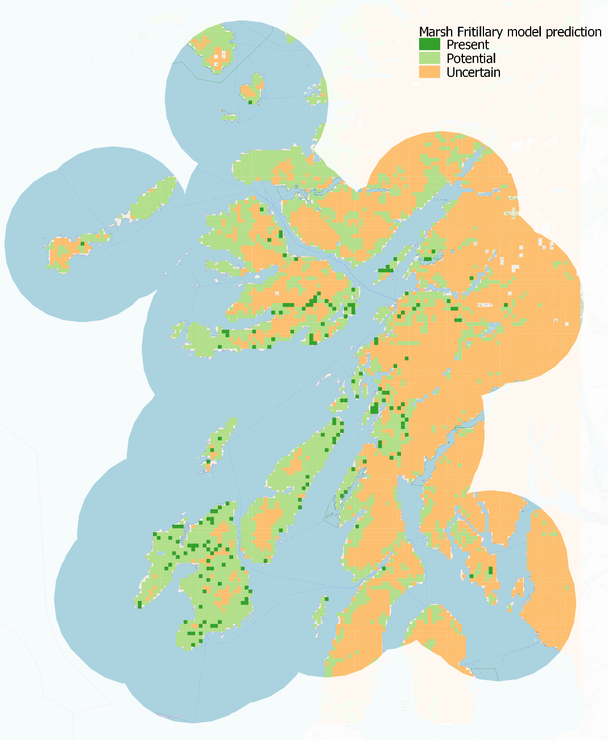

## Provide spatial layers

### Once we have decided on the appropriate threshold from the options provided, a vector layer will be created for use by Forestry Advisors. This resource will be accessed online e.g. via the Land Information Search and will provide a summary of the relevant considerations when designing a tree planting scheme. To give context to the scale of the model outcomes, a count of the number of squares in the region (Table 1) and compared to the area of Scotland (Table 2) is summarised below:

Table 1: Count of the number of squares within each category (present, potential, uncertain) at the three threshold levels and the percentages out of total number of 1km squares in the modelled region (11,930).

|  |  |  |  |
| --- | --- | --- | --- |
| Derived Category | Threshold 0.5 | Threshold 0.346 | Threshold 0.183 |
| Present | 184 (1.5%) | 184 (1.5%) | 184 (1.5%) |
| Potential | 251 (2.1%) | 921 (7.7%) | 3457 (29%) |
| Uncertain | 11495 (96.4%) | 10825 (90.7%) | 8289 (69.5%) |

Table 2: The percentage of 1km squares in different categories for different thresholds when considering all 1km squares in Scotland based on the estimate of 86, 285 1km squares in Scotland.

|  |  |  |  |
| --- | --- | --- | --- |
| Derived Category | Threshold 0.5 | Threshold 0.346 | Threshold 0.183 |
| Present | 0.21 | 0.21 | 0.21 |
| Potential | 0.29 | 1.07 | 4.01 |
| Uncertain | 13.32 | 12.55 | 9.61 |

### The instructions associated with the three categories will be decided between Scottish Forestry and Butterfly Conservation Scotland but some suggestions are outlined below:

**Present:** High potential for Marsh Fritillary to be present. Imperative to map areas of abundant devil’s-bit Scabious and undertake targeted survey of adults (end of May through June) or preferably larval webs (August and September) to determine the current status of the butterfly at the site. Ensure all occupied habitat is avoided/excluded from any planting or woodland expansion scheme. Contact Tom Prescott for further advice.

**Potential:** Potential for Marsh Fritillary to be present. Map areas of abundant devil’s-bit Scabious to ensure that these areas are avoided/excluded from the planting scheme. Contact Tom Prescott for further advice.

**Uncertain:** As the model predicts Marsh Fritillary is unlikely to be present there is no requirement to undertake any specific pre-application Marsh Fritillary surveys. However, best practice dictates that any areas of abundant devil’s-bit scabious should be avoided/excluded. If in doubt contact Tom Prescott for further advice.

## Next steps

Working with Scottish Forestry, we need to select the model threshold level from the three options provided and specify the text available to users. One area that requires clarification is the area of devil’s-bit scabious within the potential areas. Specifically, it would be ideal to quantify the size of a devil’s-bit scabious area as 0.5ha such that if the food plant is less than 0.5ha (in total or continuous) then tree planting is possible but if devil’s-bit scabious areas greater than 0.5 ha should be excluded from planting and/or undertake survey of Marsh Fritillary adults or larval webs.

Once the spatial layer and its attributes have been specified and the final risk layer is ready for use, we can consider other species to model. Currently, our suggested species would be Northern Brown Argus, Small Dark Yellow Underwing and Kentish Glory.References

Hollis, D.; McCarthy, M.; Kendon, M.; Legg, T.; Simpson, I. (2019): HadUK-Grid Gridded Climate Observations on a 1km grid over the UK, v1.0.1.0 (1862-2018). Centre for Environmental Data Analysis, 14 November 2019. doi:10.5285/d134335808894b2bb249e9f222e2eca8

Rowland, C.S.; Morton, R.D.; Carrasco, L.; McShane, G.; O'Neil, A.W.; Wood, C.M. (2017). Land Cover Map 2015 (1km percentage target class, GB). NERC Environmental Information Data Centre. [**https://doi.org/10.5285/505d1e0c-ab60-4a60-b448-68c5bbae403e**](https://doi.org/10.5285/505d1e0c-ab60-4a60-b448-68c5bbae403e)

Wilfried Thuiller, Damien Georges, Robin Engler and Frank Breiner (2019). biomod2: Ensemble Platform for Species Distribution Modeling. R package version 3.3-7.1. https://CRAN.R-project.org/package=biomod2

Thuiller, W., Lafourcade, B., Engler, R., & Araújo, M. B. (2009). BIOMOD–a platform for ensemble forecasting of species distributions. Ecography, 32, 369–373. https://doi.org/10.1111/j.1600-0587.2008.05742.x

1. <https://www.gov.scot/publications/protecting-scotlands-future-governments-programme-scotland-2019-20/pages/5/>